Title
Customer Segmentation Analysis using Machine Learning (K-Means Clustering)

Objective
The objective of this project is to analyze customer data and group similar customers into segments using clustering techniques. This helps in understanding customer behavior and designing targeted marketing strategies.
Dataset Overview
The dataset contains customer demographic and behavioral information such as:
- Gender
- Age
- Profession
- Spending Score
- Family Size
- Work Experience
- Graduation status

Data Cleaning Process
The following data cleaning steps were performed:
- Handled missing values using mode and median
- Filled categorical missing values (Ever_Married, Graduated, Profession, Var_1)
- Filled numerical missing values (Work_Experience, Family_Size)
- Removed duplicate records (if any)
- Converted categorical data into numerical format using Label Encoding

Feature Selection
For clustering, the following features were selected:
- Age
- Work_Experience
- Family_Size
- Spending_Score
These features were chosen because they best represent customer behavior.

Methodology (K-Means Clustering)
K-Means clustering algorithm was applied to group customers into 4 clusters based on similarity in their features.
Steps:
- Selected optimal number of clusters (k=4)
- Applied K-Means algorithm
- Assigned cluster labels to each customer

Visualizations
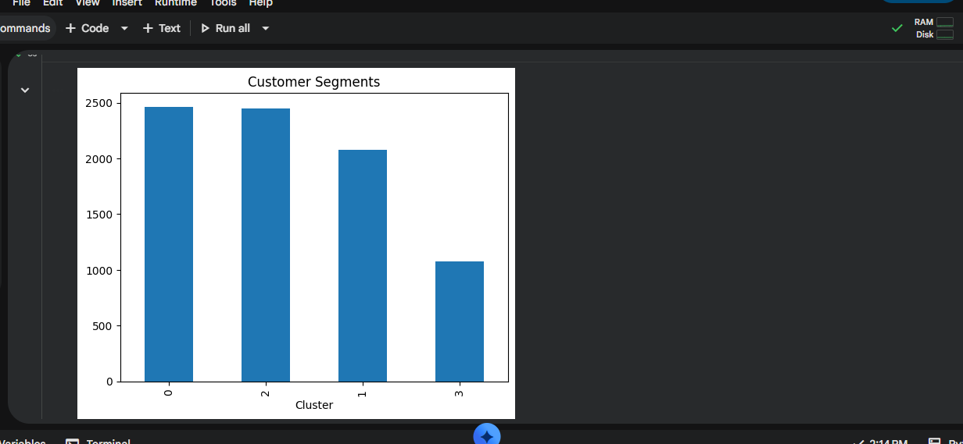
- Bar chart showing number of customers in each cluster
- Cluster distribution visualization

Key Insights
- Customers are clearly divided into 4 distinct groups
- Some clusters represent high-value customers with higher spending scores
- Some clusters represent low-income or low-spending customers
- Age and spending behavior strongly influence segmentation
- Family size also impacts customer spending patterns
Cluster Interpretation
- Cluster 0: Low spending young customers
- Cluster 1: Middle-aged average customers
- Cluster 2: High-value premium customers
- Cluster 3: Family-oriented moderate spenders

Business Recommendations

High Value Customers (Cluster 2)
- Offer premium loyalty programs
- Provide exclusive discounts and early access offers

Medium Customers (Cluster 1 & 3)
- Provide combo offers and seasonal discounts
- Increase engagement through promotions

Low Value Customers (Cluster 0)
- Offer entry-level discounts
- Run awareness campaigns to increase engagement

Conclusion
The clustering analysis successfully segmented customers into meaningful groups. These insights can help businesses improve targeted marketing strategies, increase customer retention, and maximize revenue.

